**Question :**

Is the following implementation of hashCode() legal?

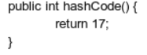

**Solution :**

The hashCode() given in the question is a legal one. We can use this code for any hashtable but it is not recommended to use since all the inputs are sent to a single index value ‘17’. If we do use this then there will be N-1 collisions in the table (where N is the number of inputs). The load factor of the table gets increased and the searching for the element gets more time complexity. So, it will lead to an improper use of HashTable.